**Activity: Create virtual network in Azure**

* Manual Steps:

Create resource group  
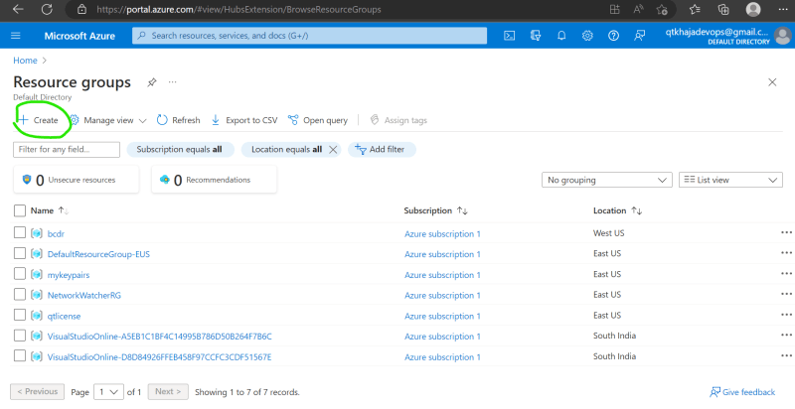  
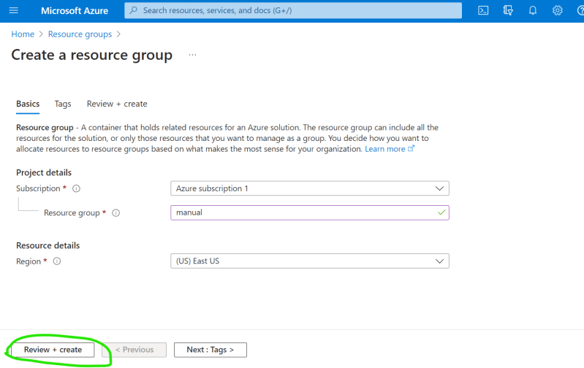

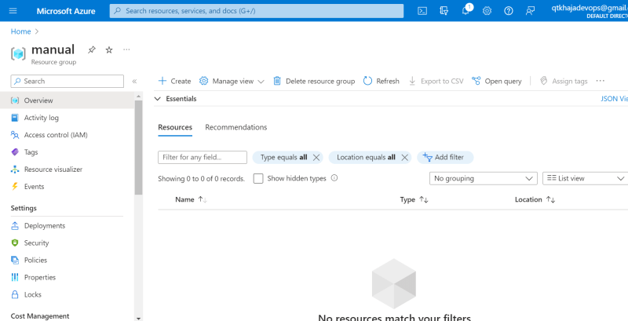

Create a VNET with cidr range 192.168.0.0/16  
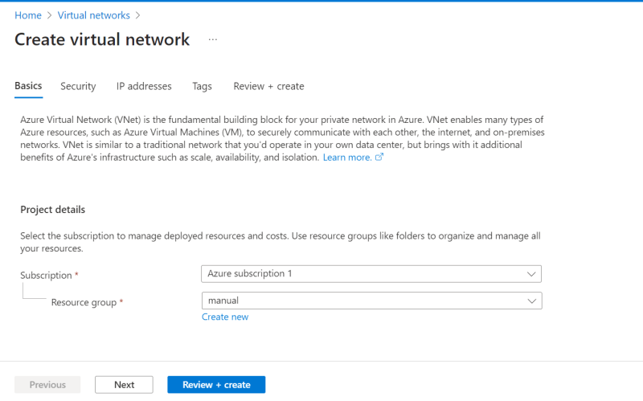

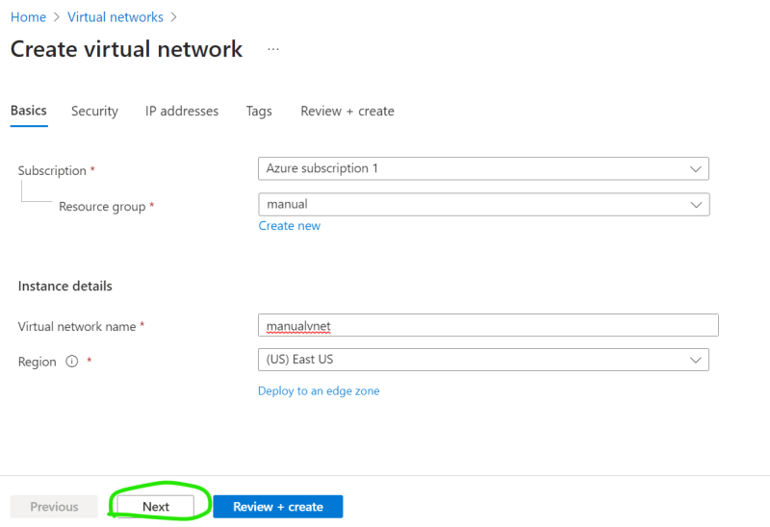

**Writing template for the above in terraform**

* Terraform takes the folder as input and reads all the .tf files and while validating,applying or destroying tries to treat all fo the .tf files as one file.
* To Create dependencies we can use depends on meta argument <https://developer.hashicorp.com/terraform/language/meta-arguments/depends_on>
* The resource name in terraform is <resource_type>.<name>

Code:

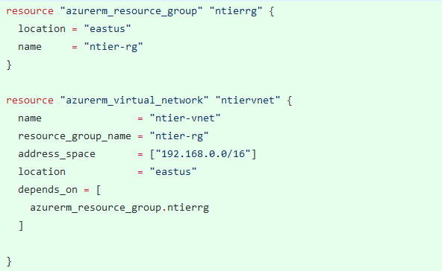

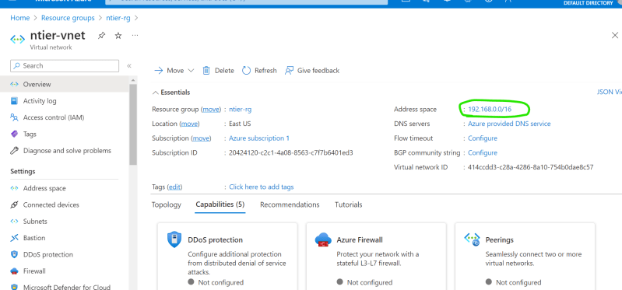

* Note:
  + The commands which we started following init, fmt, validate, apply

**Focus Points**

* To Work effectively with terrform templates we need to understand Hashicorp Configuration Language
* How to parametrized the template